Project Development Phase
Model Performance Test

Date | 02 October, 2026
Team ID | SWTID-2026-3664
Project Name | Script-Controlled ACL – Restrict Record Access Based on Field Value
Maximum Marks

Model Performance Testing:
Project team shall fill the following information in model performance testing template.
S.No. | Parameter | Screenshot / Values
 | Records Rendered | 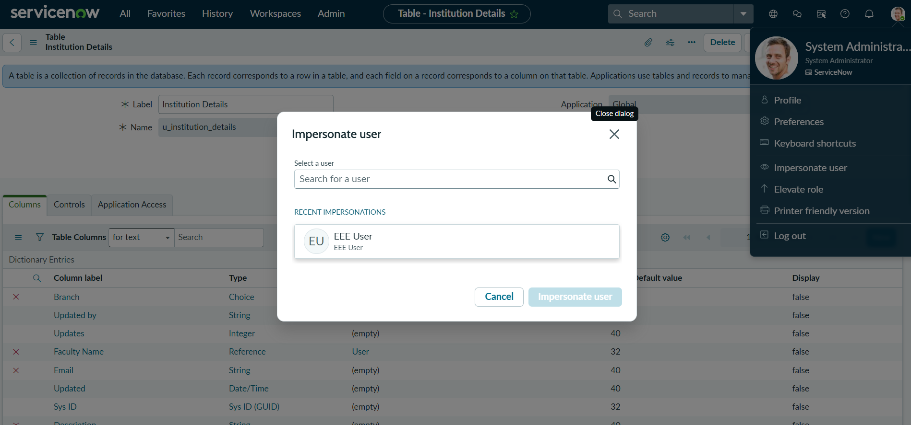
 | Access Validation | 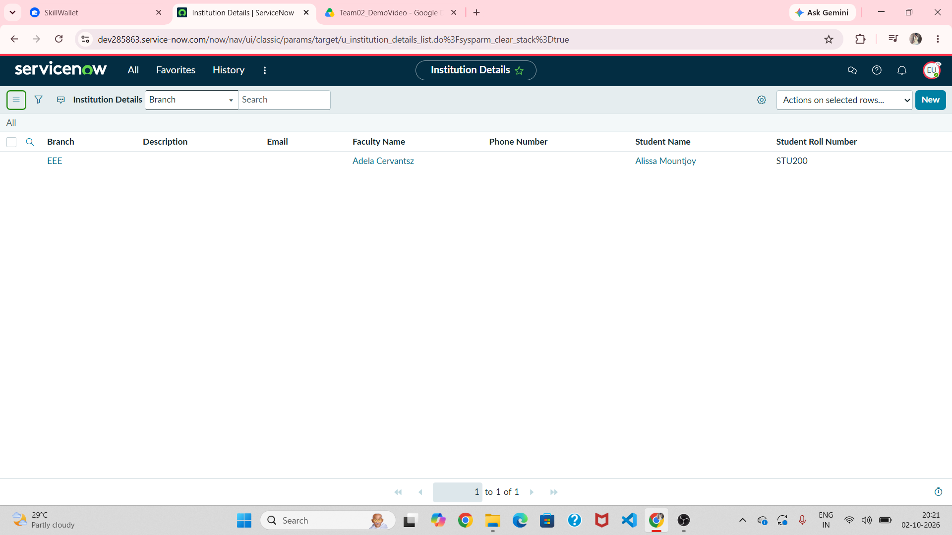
3. | Utilization of ACL Conditions | 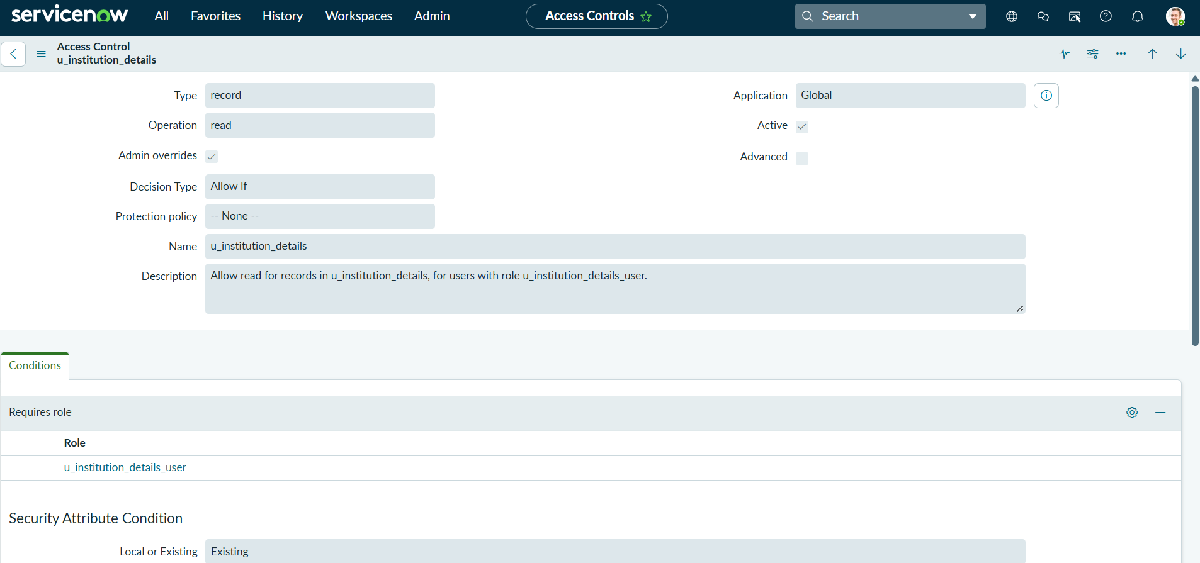
4. | ACL Scripts Used | 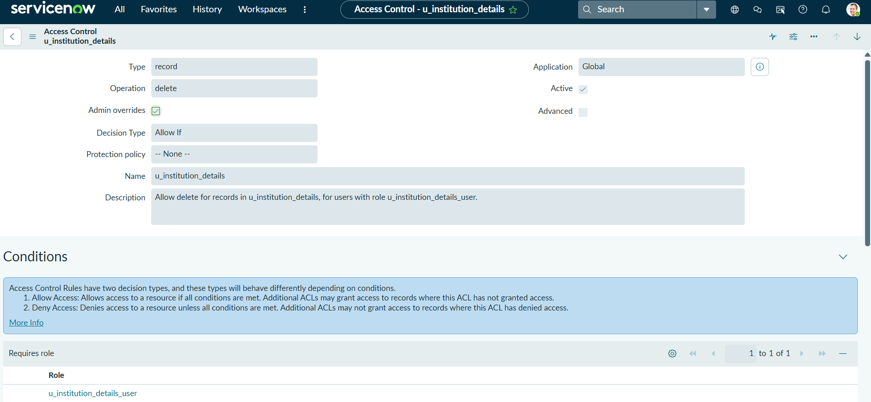
5. | Access Control Design | No. of ACL operations: 4 (READ, CREATE, WRITE, DELETE)
6 | Record Access Design | Access is controlled consistently across authorized and unauthorized users based on configured ACL rules.

